A Survey of GANs as an Image Augmentation Technique

## Abstract

## Introduction

Generative adversarial networks (GANs) are an adversarial method to generate new data from noise by pitting a generator against a discriminator and training in a zero-sum game trying to find a Nash Equilibrium.

## Background

## GANs for Image Augmentation

### Intra-Class Imbalance

In the previous section we discussed about imbalance between difference classes in the dataset, but another common issue faced that is crucial for the network to generalize well, i.e. in particular several samples in the same class could be very diverse, an evident example is that of automatic defect detection in manufacturing environments, where the defects of different subclasses are all classified as defects, the defects themselves could be very diverse in nature. To resolve this issue Lijyun Huang et.al (2019) came up with AC-GAN (Actor-Critic Generative Adversarial Network) data augmentation technique, which efficiently improves similarity of fake data of all subclasses, by using a novel loss function that adapts to intra-class data distribution, which when used to train a neural network results in a classification model with better accuracy. The experiments made in their paper shows that the higher the heterogeneity among data in the same class, larger the improvements AC-GAN can achieve. [3]

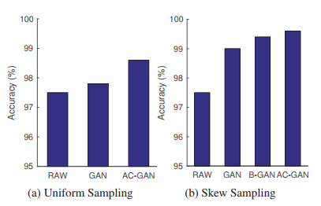

Figure Performance comparison of AC-GAN

### Inter-Class Imbalance

A common problem faced during training of neural networks in real word for multi-class classification is that number of samples of some classes dominate over other classes, this leads to slower convergence of the network, also the learner becomes more biased towards the majority class, and may even ignore the minority class.[28] The model then fails to generalize well over the dataset, medical image analysis is a good example where such problems are faced, where for example the frequency of one class like cancer can be as high as 1000 times less than another class like healthy patient.

In the case of classical Machine Learning this problem is attempted to be mitigated by operating over the data itself, one of the common methods is to applying different weights to misclassification of examples from different classes, also under-sampling and over-sampling are widely used and proven methods.[1] In the case of CNNs this issue is addressed by performing a two-stage training, in which first the network is trained on the imbalanced dataset and then further fine-tuned in the second stage.[2] Another way to deal with imbalanced datasets is to augment the dataset with classic techniques like rotations, mirroring, shearing, color space transforms, translation, noise injection.

GANs can also be used as a great augmentation tool to generate images of the minatory classes and balance the class frequency distribution. SOTA (state-of-the-art) GANs are not suitable for dealing with imbalanced datasets, BAGAN (Balancing GAN) proposed by Giovanni et.al (2018) [29] was the first methodology to address this topic. BAGAN trains on the entire dataset, both minority and majority classes, which enables BAGAN to learn the features of the classification problem, and then applying those to generate new minority-class images.

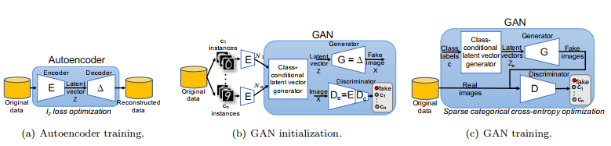

Figure Training steps involved in BAGAN methodology [4]

Unlike a traditional GAN, BAGAN has a unique training regime, autoencoder is used to initialize the GAN close to a good solution, this ensures that mode collapse does not occur. The Encoder (E) is used to initialize the first layers of Discriminator ($D_{e}$) followed by dense layer ($D_{c}$) with softmax function, the Decoder ($Δ$) is used to initialize the Generator (G). When the GAN modules are initialized, a class-conditional latent vector generator is setup that learns the probability distribution in the latent space of the different classes. This is then continued by fine tuning by carrying out a traditional GAN training.[4]

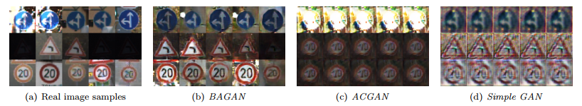

Figure Samples generated for three least represented minority classes in GT-SRB dataset [4]

From the results in the BAGAN paper we can see ACGAN fails to generate images for the minority classes and collapses, also in the second row where it was supposed to generate warning signs, ACGAN prefers to generate speed sign. Simple GAN collapses as well, although the images generated in Simple GAN are even worse.

### Medical Image Analysis

Deep Learning requires huge amount of data to get some decent result, but in the field of Medical Imaging, there are several magnitudes fewer data samples to work with than compares to large scale computer vision datasets like COCO [30] and ImageNet [31], on top of that there are issues like anonymization and privacy tagged along with the datasets obtained from medical fields [32]. There are other issues as well like, (i) The Data is usually very difficult to obtain, and even with that the number of samples is very low, (ii) The datasets usually contain high bias, with much more of healthy images than the confirmed illness ones. Quite often, because of “confirmation” images of the patient, the dataset becomes heavily skewed with bias, as the dataset gets filled with more images of the same patient. (iii) Naturally due to errors in data processing, storage and image capturing equipment, noise is introduced into the samples (e.g. marker wires, implants, prior surgery related to the illness) [7]

Jendele, et al (2019) [7] propose adversarial augmentation for enhancing classification of mammography images, by augmenting data on mammogram images on few samples, they could enhance the accuracy of their binary classifier compares to classical image augmentation techniques on the same dataset.

The model is that of a CycleGAN as inspired from Zhu et al. 2017 [5], which is applied on the dataset to generate or remove cancerous features from the mammography images.

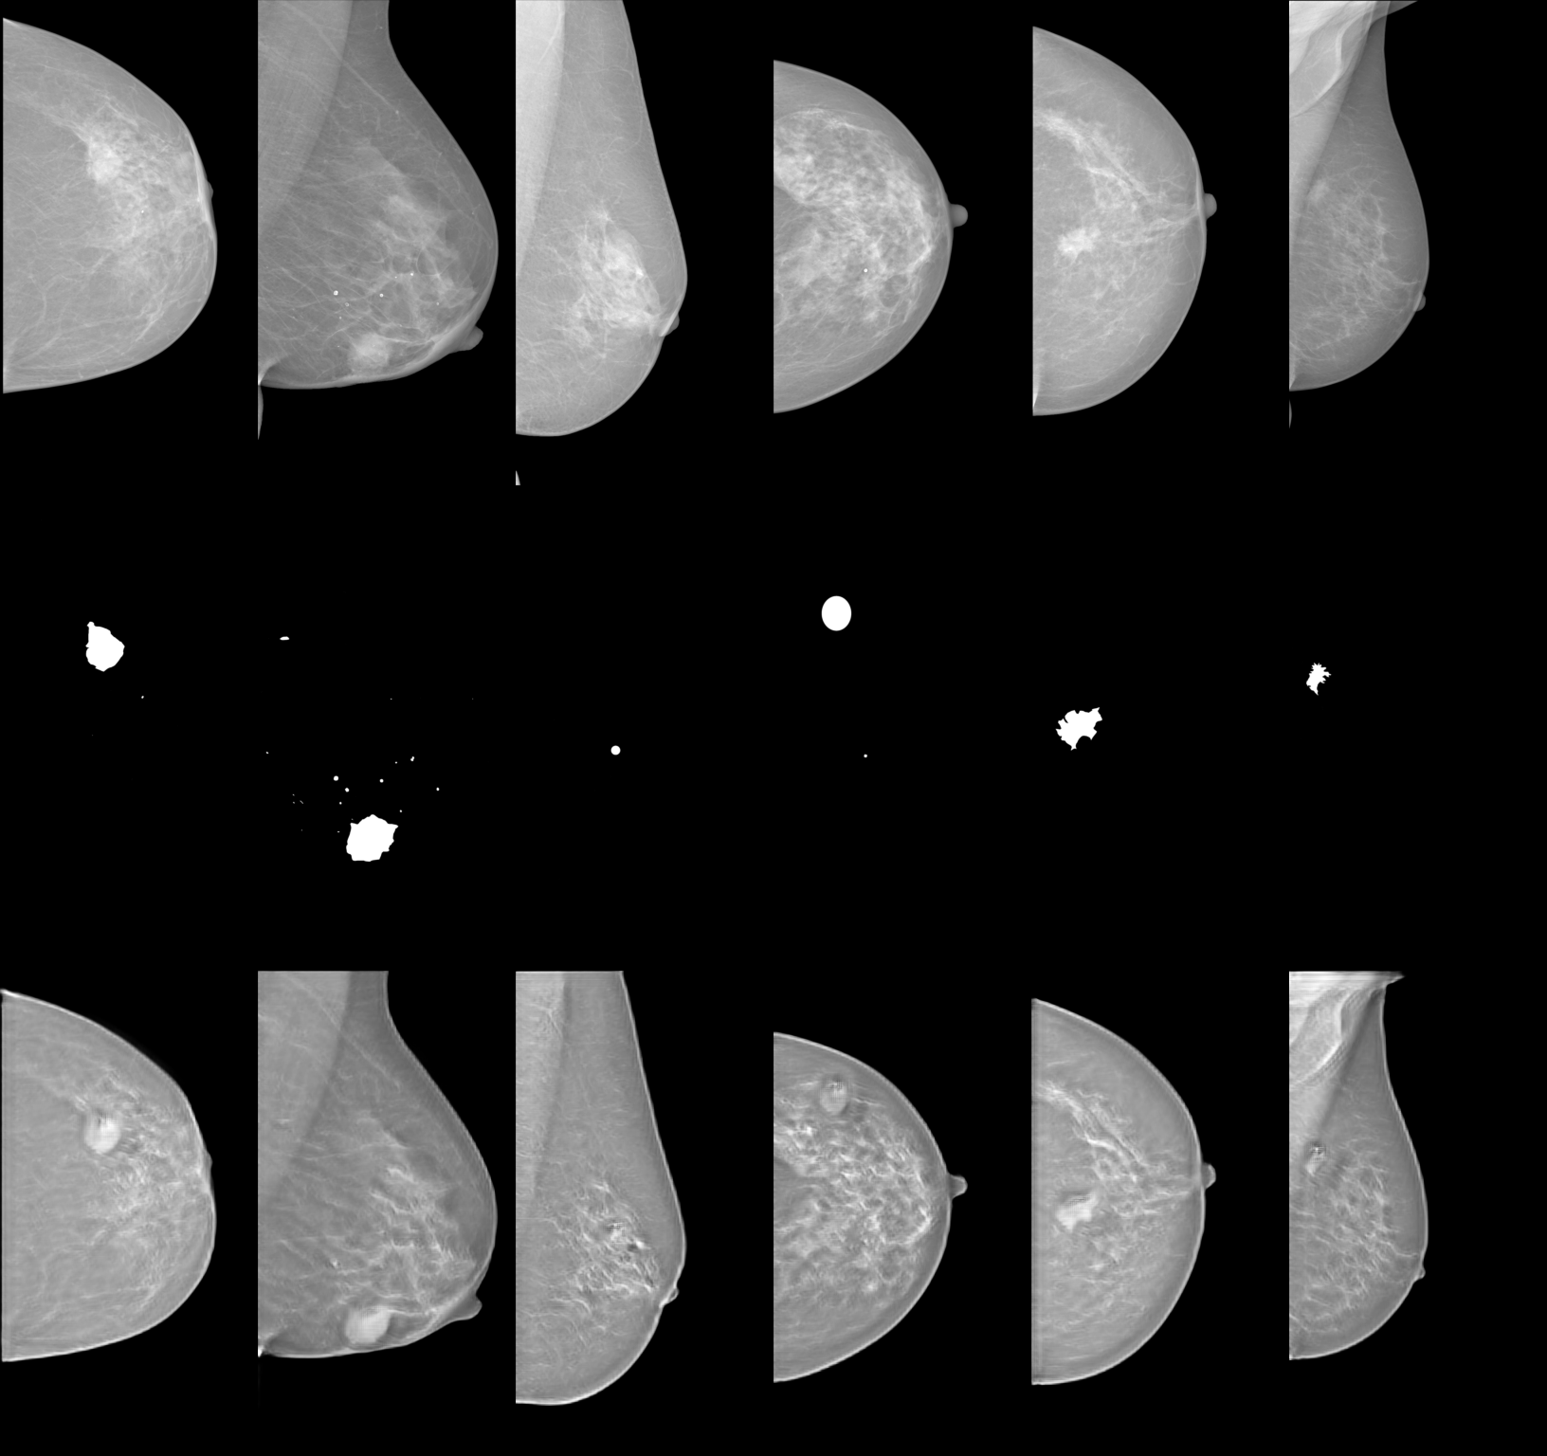

Figure Random samples generated by the CycleGAN by Jendele et al [7]

To enhance the model, on top of the generative model, another input modality was added to produce even the region of interests in the image. An example of which can be seen in Figure 4.

*TODO: Add more rows in the below table*

The below tables summarize the articles found for GANs used in medical image synthesis.[11]

|  |  |  |  |
| --- | --- | --- | --- |
| **References** | **Modalities** | **Methods** | **Remark** |
| Bowles et al (2018) [12] | CT | PGGAN | GAN derived synthetic data for brain segmentation task |
| Frid-Adar et al. (2018) [13] | CT | DCGAN | GAN for synthesizing high quality liver lesion ROIs and comparison of DCGAN and ACGAN for augmentation and their accuracies in liver lesion classification |
| Chuquicusama et al. (2018) [14] | CT | DCGAN | GAN to generate lung nodule samples. |
| Zhang et al. (2017) [15] | MRI | Semi-Coupled GAN | Two-Stage network to identify missing basal and apical slices in a CMR volume. |
| Mondal et al (2018) [16] | MRI | DCGAN | GAN used to train a segmentation model with both labeled and unlabeled data. |
| Plassard et al. (2018) [17] | MRI | DCGAN | Using GAN for unsupervised synthesis of T1-weighted brain MRI from 2D axial slices of brain MRI |
| Beers et al. (2018) [18] | MRI | PGGAN | GANs used to produce high quality medical images of fundus photographs exhibiting vascular pathology associated with retinopathy of prematurity (ROP), and multi modal magnetic resonance images of glioma. |
| Salehinejad et al. (2018) [19] | X-Ray | DCGAN | Balancing imbalanced dataset with GAN on chest X-Rays for detection of pathology across them using a DCNN |
| Madani et al. (2018) [20] | X-Ray | DCGAN | GANs used to generate data for abnormality classification in chest X-rays. |
| Baur & Navab (2018) [22] | Dermo | LAPGAN | Introduction of MelanoGAN: To generate realistic looking high-resolution images of skin legions, and comparison with SOTA DCGAN and LAPGAN. |
| Lin et al. (2019) [33] | X-Ray | ACGAN | ACGAN was used to augment data on a Limb X-Ray dataset, and transfer learning was used to train hip fracture detection on a Pelvic X-ray dataset |
| Lahiri et al. (2020) [21] | Retinal | DCGAN | GANs used to generate dataset from extremely low annotations for segmentation of blood vessels in retinal fundus images. |
| Chang Qi et al. (2020) [8] | MRI | CCGAN | Introduction of SAG-GAN for generation of MRI images for tumor classification. |
| DuMont et al. (2020) [23] | CT | DCGAN | GAN for synthetic data generation of chest radiographs with 14 different radiology findings and brain CT scans with six different intracranial hemorrhages. |
| Wang C et al. (2020) [24] | MRI | CycleGAN | GAN for cross domain image synthesis, in this paper for specifically generating pseudo-CT for PET-MR attenuation correction. |

### GAN with Attention!

Inspired with the CycleGAN and GAN based data augmentation model, Chang Qi et al (Nov 2020) [8] came up with SAG-GAN (Semi-Supervised Attention-Guided GAN) for augmentation in Medical Images. The unique feature is that, it not only generates the image features but also makes sure that that the generator is able to locate the areas that needs to be translated in each image using the attention module, this is the first paper that integrates sei-supervised attention mechanism to GANs, its semi supervised as the attention modules are trained by both adversarial loss and pixel-wise loss, the additional pixel loss pushes the attention mechanism to locate the locations of the tumors as accurately as possible.[8]

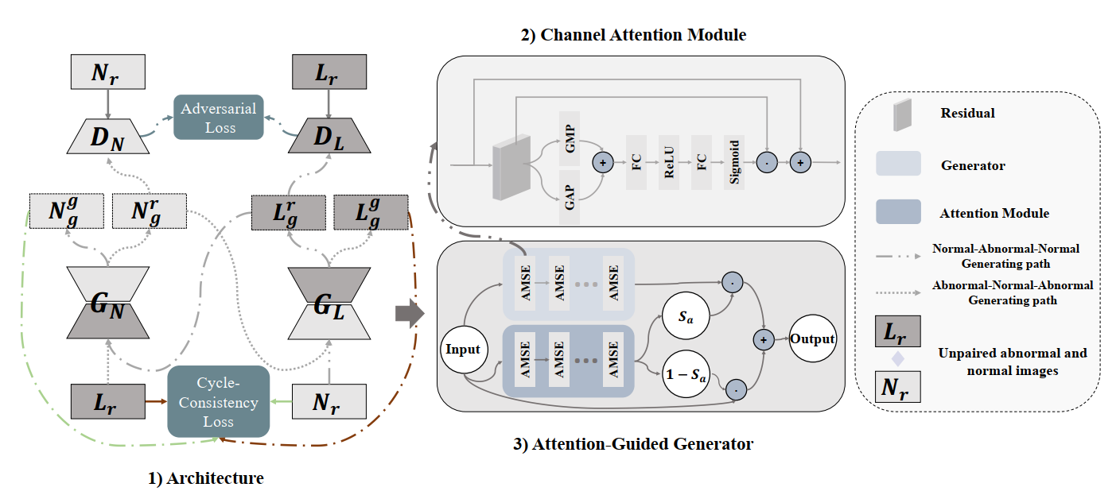

Figure Illustration of the SAGGAN by Chang Qi et al

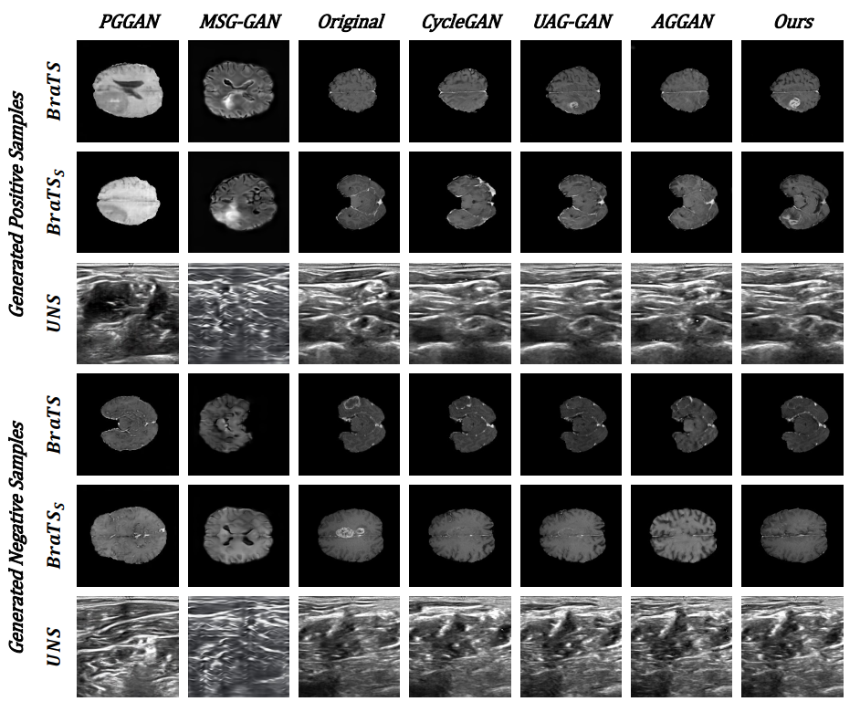

Figure Comparison of the data generated by various GANs with SAGGAN [8]

Figure 6, shows some samples generated by various GANs, this clearly depicts how well GANs can be used to generate more samples in a medical dataset, thus improving the model accuracies, compared to classical techniques like over-sampling and under-sampling, GANs can work as a really good image-augmenters!

Yi Sun et al. (2020) [9] propose an end-to-end architecture to generate 3D MR images of brain tumors and liver lesions from a deformed label map using a conditional GAN called MM-GAN.

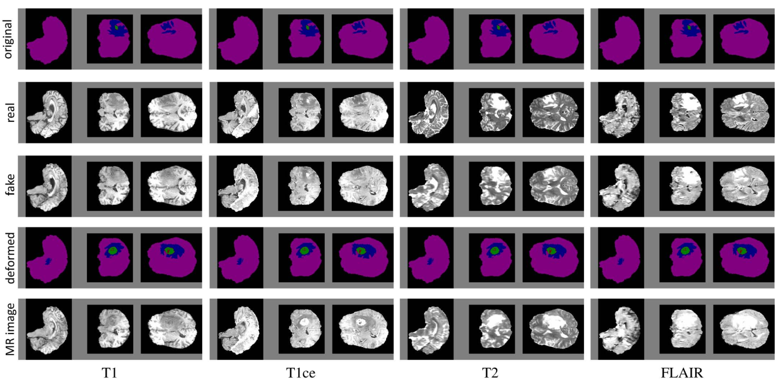

Figure Examples of synthetic data using MM-GAN

This new data generated can be shared publicly without any privacy issues, as all of the data generated by the GAN is different from the real dataset. The GAN used to generate these images is akin to 3D U-Net architecture, the difference being that the batch norm and down-sampling blocks in 3D U-Net are replaced by instance normalization layers, as they give better performance in mini batches and generative tasks, the activation function is LeakyReLU replacing the usual ReLU [9], as its more balanced and therefore learns faster.[10]

### CycleGAN

The crust of CycleGAN is “If we translate from one domain to another and back again, we must arrive where we start”, [5], Zhu et al [5] proposed a CycleGAN that can perform image-to-image translation between two unpaired image domains, this idea was further used by Xinyue Zhu et al. [6] to augment image data of emotion classification, which has imbalanced label distribution for classes like disgusted with very few samples compared to happy or sad. The key reason to choose CycleGAN over classical GAN in their paper was because GAN learns a mapping from the latent z vector (noise) of lower dimension to a higher dimension space, but while in CycleGAN, it can translate between two high dimension domains, and learns a low-dimensional manifold and also the parameters needed to map it back to the high dimension space.[6]

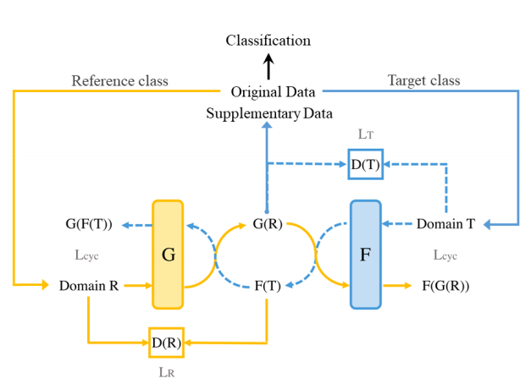

Figure Architecture of the CycleGAN proposed by Xinyue et.al for data augmentation for emotion classification

Figure 4, shows the architecture henceforth created, which consists of the two domains R, and T, and G, F are two generators, translating and , respectively, in this model is the LSGAN (Least Square GAN) loss relative to target domains. To keep the cycle consistent a cycle loss is used, namely .

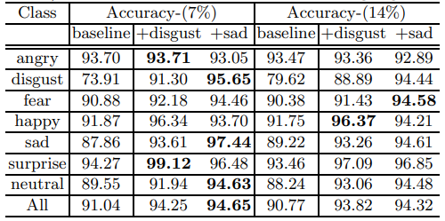

Figure Results from Xinyue et al, comparison of baseline CNN model with their proposed CNN+CycleGAN

In Figure 5, FER2013 (Facial Emotional Recognition) dataset was used to benchmark the baseline CNN model with the CNN+CycleGAN model, 7% and 14% being the amount of data taken from the dataset for test, sad and disgust being the target classes with relatively much lower number of samples. From the results it can be clearly seen that the test accuracy increases by augmentation, and the accuracy of target classes increases significantly i.e. of sad and disgust, but also something worth noticing is that the accuracy of class neural also increases by a lot.

### Training GAN with limited dataset

In all of the methods and techniques mentioned above, use a GAN on a relatively smaller dataset to generate more data, but training GAN on less data itself can be a challenging task. One key challenging problem is that the discriminator will overfit the training dataset, then its feedback to the generator becomes meaningless and training loss starts to diverge. [25, 26] In the paper Training Generative Adversarial Networks with Limited Data, they demonstrate different types of augmentations that can be applied on the dataset to prevent overfitting the discriminator, also ensuring that none of the augmentations leak into the images generated.

To achieve this, a overfitting heuristic function is used to adjust the augmentation probability.

Where the first heuristic represents the output of the validation set relative to the training set and represents the portion of the training set that gets positive discriminator outputs. is initialized to zero at first, and based on the heuristic is incremented/decremented by a fixed amount, and after every step is clamped to 0, this was called adaptive discriminator augmentation (ADA).[27]

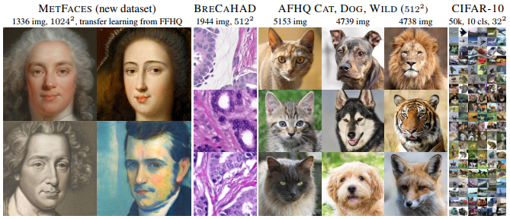

Figure Examples generated using ADA on a limited amount of training data on several different datasets.

## Discussion

## Future Work

## Conclusion

## Acknowledgements

## Bibliography

[1] Buda, M., Maki, A., & Mazurowski, M. A. (2018). A systematic study of the class imbalance problem in convolutional neural networks. Neural Networks, 106, 249-259.

[2] He, H., & Garcia, E. A. (2009). Learning from Imbalanced Data IEEE Transactions on Knowledge and Data Engineering v. 21 n. 9.

[3] Huang, L., Lin, K. C. J., & Tseng, Y. C. (2019, July). Resolving intra-class imbalance for GAN-based image augmentation. In 2019 IEEE International Conference on Multimedia and Expo (ICME) (pp. 970-975). IEEE.

[4] Mariani, G., Scheidegger, F., Istrate, R., Bekas, C., & Malossi, C. (2018). Bagan: Data augmentation with balancing gan. arXiv preprint arXiv:1803.09655.

[5] Zhu, J. Y., Park, T., Isola, P., & Efros, A. A. (2017). Unpaired image-to-image translation using cycle-consistent adversarial networks. In Proceedings of the IEEE international conference on computer vision (pp. 2223-2232).

[6] Zhu, X., Liu, Y., Li, J., Wan, T., & Qin, Z. (2018, June). Emotion classification with data augmentation using generative adversarial networks. In Pacific-Asia conference on knowledge discovery and data mining (pp. 349-360). Springer, Cham.

[7] Jendele, L., Skopek, O., Becker, A. S., & Konukoglu, E. (2019). Adversarial Augmentation for Enhancing Classification of Mammography Images. arXiv preprint arXiv:1902.07762.

[8] Qi, C., Chen, J., Xu, G., Xu, Z., Lukasiewicz, T., & Liu, Y. (2020). SAG-GAN: Semi-Supervised Attention-Guided GANs for Data Augmentation on Medical Images. arXiv preprint arXiv:2011.07534.

[9] Sun, Y., Yuan, P., & Sun, Y. (2020, August). MM-GAN: 3D MRI Data Augmentation for Medical Image Segmentation via Generative Adversarial Networks. In 2020 IEEE International Conference on Knowledge Graph (ICKG) (pp. 227-234). IEEE.

[10] Xu, B., Wang, N., Chen, T., & Li, M. (2015). Empirical evaluation of rectified activations in convolutional network. arXiv preprint arXiv:1505.00853.

[11] Singh, N. K., & Raza, K. (2020). Medical Image Generation using Generative Adversarial Networks. arXiv preprint arXiv:2005.10687.

[12] Bowles, C., Chen, L., Guerrero, R., Bentley, P., Gunn, R., Hammers, A., ... & Rueckert, D. (2018). Gan augmentation: Augmenting training data using generative adversarial networks. arXiv preprint arXiv:1810.10863.

[13] Frid-Adar, M., Diamant, I., Klang, E., Amitai, M., Goldberger, J., & Greenspan, H. (2018). GAN-based synthetic medical image augmentation for increased CNN performance in liver lesion classification. Neurocomputing, 321, 321-331.

[14] Chuquicusma, M. J., Hussein, S., Burt, J., & Bagci, U. (2018, April). How to fool radiologists with generative adversarial networks? a visual turing test for lung cancer diagnosis. In 2018 IEEE 15th international symposium on biomedical imaging (ISBI 2018) (pp. 240-244). IEEE.

[15] Zhang, L., Gooya, A., & Frangi, A. F. (2017, September). Semi-supervised assessment of incomplete LV coverage in cardiac MRI using generative adversarial nets. In International Workshop on Simulation and Synthesis in Medical Imaging (pp. 61-68). Springer, Cham.

[16] Mondal, A. K., Dolz, J., & Desrosiers, C. (2018). Few-shot 3d multi-modal medical image segmentation using generative adversarial learning. arXiv preprint arXiv:1810.12241.

[17] Bermudez, C., Plassard, A. J., Davis, L. T., Newton, A. T., Resnick, S. M., & Landman, B. A. (2018, March). Learning implicit brain MRI manifolds with deep learning. In Medical Imaging 2018: Image Processing (Vol. 10574, p. 105741L). International Society for Optics and Photonics.

[18] Beers, A., Brown, J., Chang, K., Campbell, J. P., Ostmo, S., Chiang, M. F., & Kalpathy-Cramer, J. (2018). High-resolution medical image synthesis using progressively grown generative adversarial networks. arXiv preprint arXiv:1805.03144.

[19] Salehinejad, H., Valaee, S., Dowdell, T., Colak, E., & Barfett, J. (2018, April). Generalization of deep neural networks for chest pathology classification in x-rays using generative adversarial networks. In 2018 IEEE International Conference on Acoustics, Speech and Signal Processing (ICASSP) (pp. 990-994). IEEE.

[20] Madani, A., Moradi, M., Karargyris, A., & Syeda-Mahmood, T. (2018, April). Semi-supervised learning with generative adversarial networks for chest x-ray classification with ability of data domain adaptation. In 2018 IEEE 15th International Symposium on Biomedical Imaging (ISBI 2018) (pp. 1038-1042). IEEE.

[21] Lahiri, A., Jain, V., Mondal, A., & Biswas, P. K. (2020, October). Retinal Vessel Segmentation Under Extreme Low Annotation: A Gan Based Semi-Supervised Approach. In 2020 IEEE International Conference on Image Processing (ICIP) (pp. 418-422). IEEE.

[22] Baur, C., Albarqouni, S., & Navab, N. (2018). MelanoGANs: high resolution skin lesion synthesis with GANs. arXiv preprint arXiv:1804.04338.

[23] DuMont Schütte, A., Hetzel, J., Gatidis, S., Hepp, T., Dietz, B., Bauer, S., & Schwab, P. (2020). Overcoming Barriers to Data Sharing with Medical Image Generation: A Comprehensive Evaluation. arXiv e-prints, arXiv-2012.

[24] Wang, C., Yang, G., Papanastasiou, G., Tsaftaris, S. A., Newby, D. E., Gray, C., ... & MacGillivray, T. J. (2020). DiCyc: GAN-based deformation invariant cross-domain information fusion for medical image synthesis. Information Fusion, 67, 147-160.

[25] Arjovsky, M., & Bottou, L. (2017). Towards principled methods for training generative adversarial networks. arXiv preprint arXiv:1701.04862.

[26] Zhang, D., & Khoreva, A. (2018). PA-GAN: Improving GAN training by progressive augmentation.

[27] Karras, T., Aittala, M., Hellsten, J., Laine, S., Lehtinen, J., & Aila, T. (2020). Training generative adversarial networks with limited data. arXiv preprint arXiv:2006.06676.

[28] Johnson, J. M., & Khoshgoftaar, T. M. (2019). Survey on deep learning with class imbalance. Journal of Big Data, 6(1), 27.

[29] Mariani, G., Scheidegger, F., Istrate, R., Bekas, C., & Malossi, C. (2018). Bagan: Data augmentation with balancing gan. arXiv preprint arXiv:1803.09655.

[30] Lin, T. Y., Maire, M., Belongie, S., Hays, J., Perona, P., Ramanan, D., ... & Zitnick, C. L. (2014, September). Microsoft coco: Common objects in context. In European conference on computer vision (pp. 740-755). Springer, Cham.

[31] Deng, J., Dong, W., Socher, R., Li, L. J., Li, K., & Fei-Fei, L. (2009, June). Imagenet: A large-scale hierarchical image database. In 2009 IEEE conference on computer vision and pattern recognition (pp. 248-255). Ieee.

[32] Shin, H. C., Tenenholtz, N. A., Rogers, J. K., Schwarz, C. G., Senjem, M. L., Gunter, J. L., ... & Michalski, M. (2018, September). Medical image synthesis for data augmentation and anonymization using generative adversarial networks. In International workshop on simulation and synthesis in medical imaging (pp. 1-11). Springer, Cham.

[33] Lin, Y. J., & Chung, I. F. (2019, November). Medical Data Augmentation Using Generative Adversarial Networks: X-ray Image Generation for Transfer Learning of Hip Fracture Detection. In 2019 International Conference on Technologies and Applications of Artiﬁcial Intelligence (TAAI) (pp. 1-5). IEEE.